Attachment 13: The new Supply/Demand report, when run for the year preceding a Dislocated Worker’s WIOA application date, can be used to document “unlikely to return” when the applicant’s ONET of dislocation falls in the lowest third in terms of lowest demand/highest supply.
The Supply/Demand Report is currently located in Connecting Colorado’s Report Menu at the bottom right corner of the screen.
- Select Supply Demand (Test)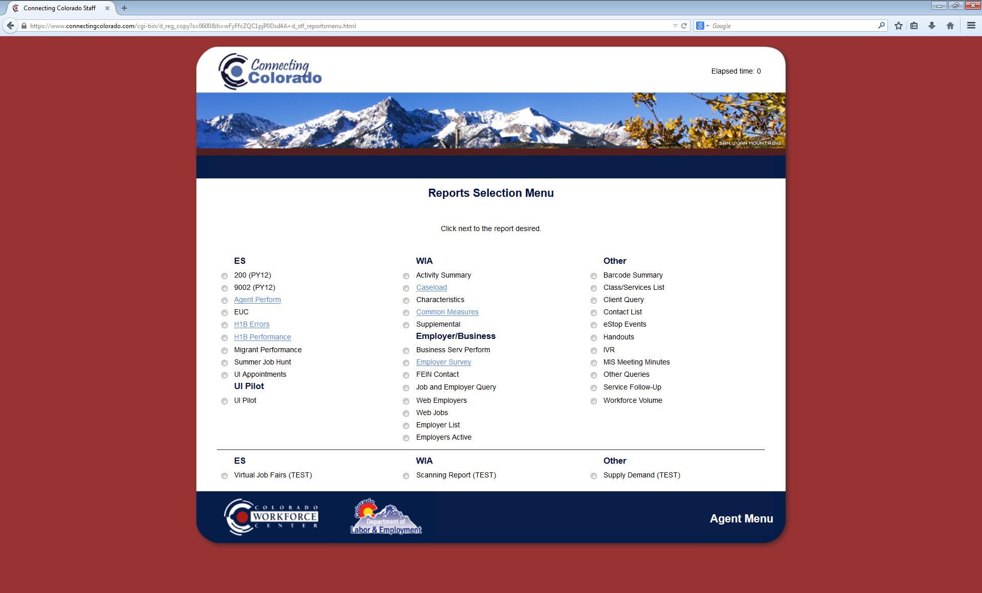

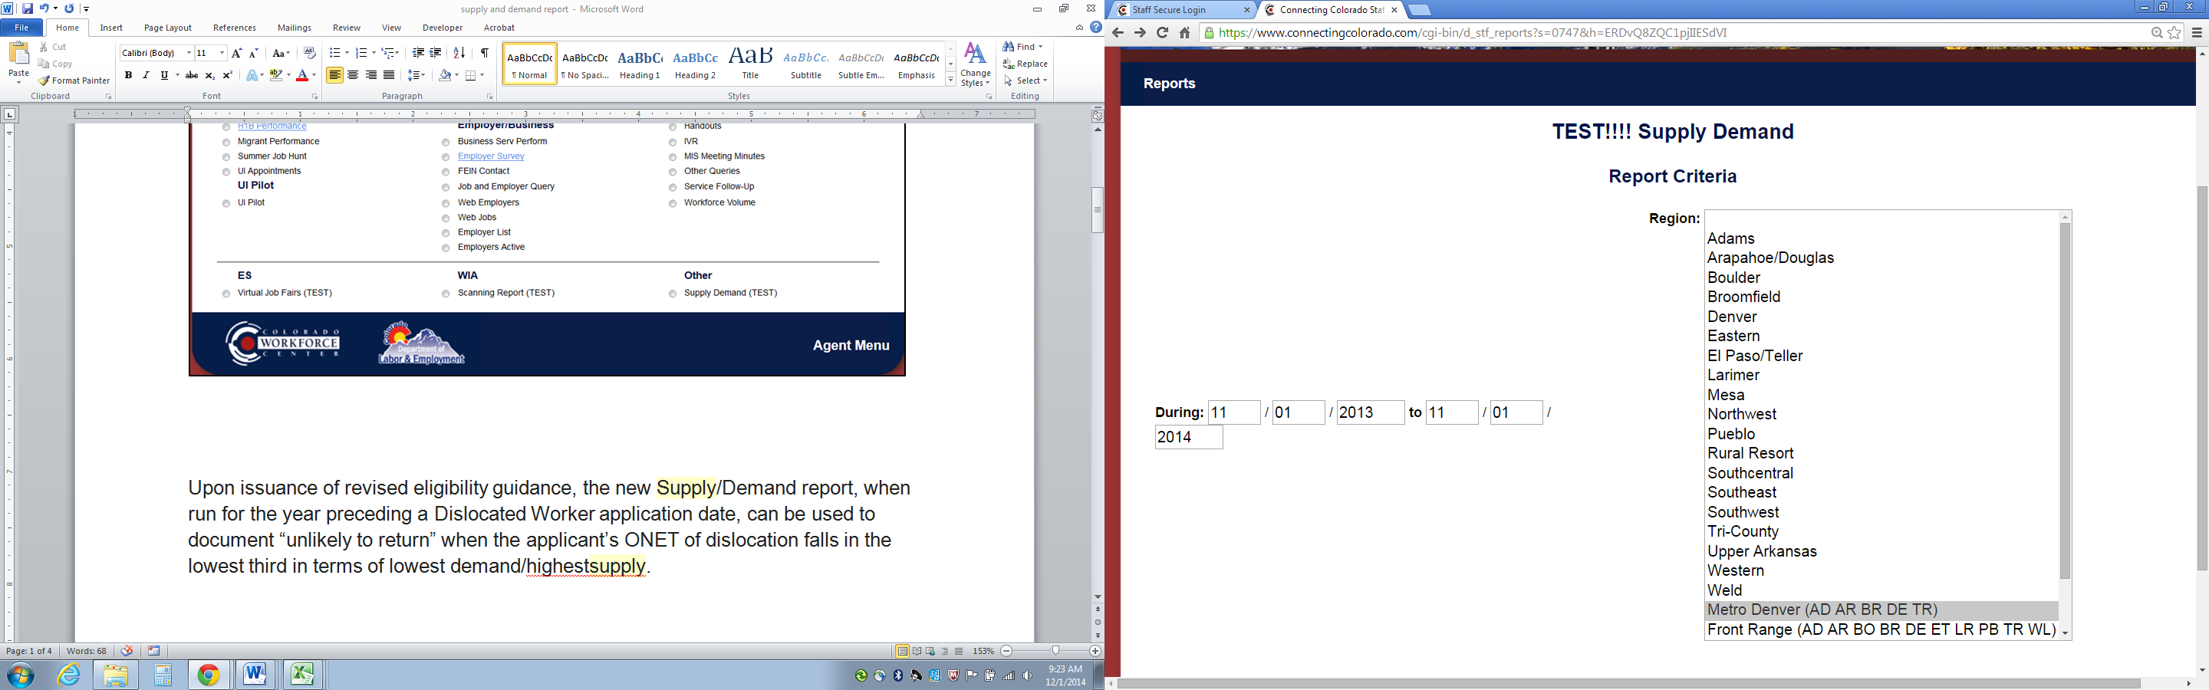
- In the During fields, enter the year preceding a Dislocated Worker’s application date to determine “unlikely to return” eligibility.

- Select the appropriate Region, State or
Super Region (Metro Denver, Front Range)
based on where the Dislocated Worker
applicant is searching for employment.

- Review the report to locate the 2-digit O*Net code associated with the job of dislocation. The Supply/Demand report can be used to document “unlikely to return” when the applicant’s O*Net of dislocation falls in the lowest third in terms of lowest demand/highest supply. Print the report and place it in the applicant case file with a note that this report is documenting unlikely to return.
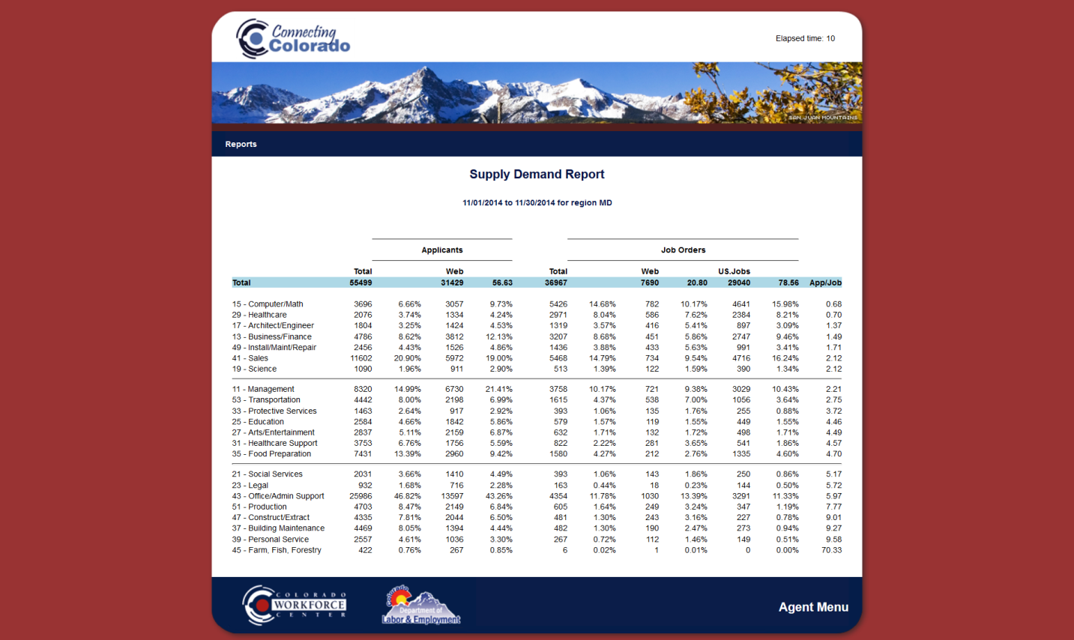
Lowest Demand/ Highest Supply
Mid-range Demand/ Mid-range Supply
Highest Demand/ Lowest Supply

