Attachment 14
YOUTH IN POVERTY INTERACTIVE MAP – Change 2

A youth who lives in a high poverty area is automatically considered to be a low-income individual for the WIOA youth program. A high-poverty area is a Census tract, a set of contiguous Census tracts, Indian Reservation, tribal and/or Native Alaskan Village or county that has a poverty rate of at least 25 percent as set every 5 years using American Community Survey 5-Year data. To access Colorado’s map, click on the following link:
https://dola.colorado.gov/gis-php/files/projects/PovertyComprehensive/comp_poverty.html

- If you click on the Legend, you will see that census tracks with at least a 25% poverty rate are in red tones. Those below 25% are in green tones. Click again to hide the Legend.

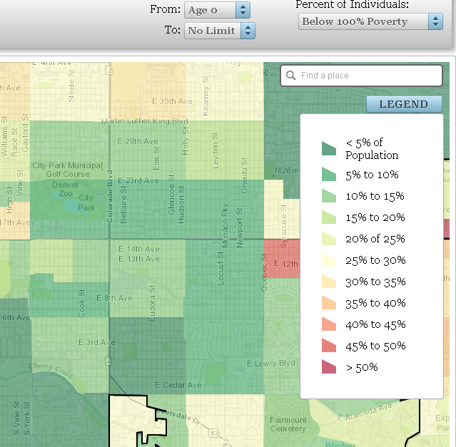
- Enter the address of the youth for whom you are determining low income into the “Find a Place” box. (There is no need to enter an age range or change the Below 100% Poverty). Press/click enter and view the resulting map, which may display a single census track or a large area of contiguous
census tracks such as a city or county.
Note on Number Keys: On some computers, you’ll need to use the number keys at the top of the keypad instead of those to the right.
- You can then use the Plus or Minus on the map to size the map; and/or you can click and drag the map to the right to place the spot showing the actual site closer to the Find a Place box.
- Then place your mouse over the map and click to bring up the Census Tract data box. Try to have this box appear close to the Find a Place box without covering up the actual site (see example below). This can take a few tries.
- Note the Percent figure in the second column/third row and the plus (ignore the minus) Percent figure in the third column/third row of the Census Tract box. If the amount of the two percentages added together is 25% or more, then you may use this map to document low income.
- To capture a screen print of the map, use your Windows Accessory called Snipping Tool. This tool allows you to define the section of the screen you want to capture; then the program automatically places the image in a file.
- Rather than saving the file, use the Edit function to create a copy, and paste the image into a Word file. Size the image, if necessary, to make sure all data is large enough to see clearly.
- Leave enough room for adding text above the image with the name and address of the youth, plus a note that this map is to document low income for WIOA Youth Program eligibility.
- Place a copy of this document in the customer case file.

