Attachment 1: Procedures for Documenting Credential Attainment in connecting Colorado

Credential Attainment is the percentage of those participants enrolled in an education or training program (excluding those in OJT and customized training) who attained a recognized postsecondary credential or a secondary school diploma, or its recognized equivalent, during participation in or within one year after exit from the program.

A participant who has attained a secondary school diploma or its recognized equivalent is included in the percentage of participants who have attained a secondary school diploma or its recognized equivalent only if the participant also is employed or is enrolled in an education or training program leading to a recognized postsecondary credential within one year after exit from the program.

Methodology: Calculation includes participants who exited from a program and were in either a postsecondary education or training program (other than an OJT and customized training) OR in a secondary education program at or above the 9th grade level without a secondary school diploma or its equivalent.

Numerator: The number of participants who exited during the reporting period who obtained a recognized postsecondary credential during the program or within one year after exit OR those who were in a secondary education program and obtained a secondary school diploma or its recognized equivalent during the program or within one year after exit and were also employed, or in an education or training program leading to a recognized postsecondary credential within one year after exit

______________________________ DIVIDED BY ______________________________

Denominator: The number of participants enrolled in an education or training program (excluding those in OJT and customized training) who exited during the reporting period

This indicator measures attainment of two types of credentials:
- Recognized postsecondary credential; and
- Secondary school diploma or its recognized equivalent.

- Definition of a Recognized Postsecondary Credential

A recognized postsecondary credential is defined as a credential consisting of:
- An industry-recognized certificate or certification;
- A certificate of completion of an apprenticeship;
- A license recognized by the State involved or Federal government; or
- An associate or baccalaureate degree (graduate degrees do not count for WIOA AD, DW, or YT programs).

A recognized postsecondary credential is awarded in recognition of an individual’s attainment of measurable technical or industry/occupational skills necessary to obtain employment or advance within an industry/occupation. These technical or industry/occupational skills generally are based on standards developed or endorsed by employers or industry associations.

Certificates awarded by workforce development boards (WDBs) and work readiness certificates are not included in this definition because neither type of certificate is recognized industry wide, nor documents the measurable technical or industry/occupational skills necessary to gain employment or advancement within an occupation. Likewise, such certificates must recognize technical or industry/occupational skills for the specific industry/occupation rather than general skills related to safety, hygiene, etc., even if such general skills certificates are broadly required to qualify for entry-level employment or advancement in employment.

Example credentials that DO count:
- Certified Nursing Assistant (CNA) License
- Automotive Service Excellence (ASE) Certification
- National Retail Federation Customer Service Certification
- Fork Lift Certification
- Commercial Driver’s Licenses (CDL)

Example credentials that DO NOT count:
- Occupational Safety and Health Administration (OSHA) 10 Hour Course that provides awareness of job-related common safety and health hazards
- Work/Career Readiness certificates
- Completion of an Assistive Technology training program (e.g. screen reading software)
- Completion of Orientation and Mobility training
- ServSafe certificate
- CPR and AED certification (or other first aid certification)

Organizations and institutions that award recognized postsecondary credentials include:
- State educational agency or a State agency responsible for administering vocational and technical education within a State;
- An institution of higher education (including community colleges, proprietary schools, and all other institutions of higher education that are eligible to participate in Federal student financial aid programs);
- An institution of higher education that is formally controlled, or has been formally sanctioned or chartered, by the governing body of an Indian tribe or tribes;
- A professional, industry, or employer organization (e.g., National Institute for Automotive Service Excellence certification, National Institute for Metalworking Skills, Inc., Machining Level I credential) or product manufacturer or developer (e.g., recognized Microsoft Information Technology certificates, such as Microsoft Certified IT Professional (MCITP), Certified Novell Engineer, a Sun Certified Java Programmer, etc.) using a valid and reliable assessment of an individual’s knowledge, skills and abilities;
- The US Department of Labor Education and Training Administration’s Office of Apprenticeship or a recognized State Apprenticeship Agency;
- A public regulatory agency, which awards a credential upon an individual’s fulfillment of educational, work experience, or skill requirements that are legally necessary for an individual to use an occupational or professional title or to practice an occupation or profession (e.g., Federal Aviation Administration aviation mechanic license, or a State-licensed asbestos inspector);
- A program that has been approved by the Department of Veterans Affairs to offer education benefits to veterans and other eligible persons; or
- Job Corps, which issues certificates for completing career training programs that are based on industry skills standards and certification requirements.

Note: not all credentials by these entities meet the definition of a recognized postsecondary credential.

- Definition of a Secondary School Diploma or Recognized Equivalent

For the purposes of the credential attainment performance indicator, a secondary school diploma (commonly referred to as a high school diploma) is one that is recognized by a State and that is included for accountability purposes under the Elementary and Secondary Education Act of 1965 (ESEA), as amended by the Every Student Succeeds Act (ESSA). A secondary school equivalency certification signifies that a student has completed the requirements for a high school education. The types of recognized equivalents, for those not covered under ESEA, that would satisfy this performance indicator are those recognized by a State. Examples include:
- Obtaining certification of attaining passing scores on a State-recognized high school equivalency test;
- Earning a secondary school diploma or State-recognized equivalent through a credit-bearing secondary education program sanctioned by State law, code, or regulation;
- Obtaining certification of passing a State-recognized competency based assessment; and
- Completion of a specified number of college credits.

C. Types of acceptable credentials that count toward the credential attainment indicator for the WIOA
Adult, Dislocated Worker, and Youth programs include:
- Secondary School diploma or recognized equivalent;
- Associate’s degree;
- Bachelor’s degree;
- Occupational licensure;
- Occupational certificate, including Registered Apprenticeship and Career and Technical Education educational certificates;
- Occupational certification;
- Other recognized certificates of industry/occupational skills completion sufficient to qualify for entry-level or advancement in employment.

What happens in Connecting Colorado to put an individual in the denominator?

Participants are included in the credential attainment performance indicator if they are in an educational program at the time of enrollment, or if they are active in at least one education or training program that leads to a recognized postsecondary credential or a secondary school diploma, or its recognized equivalent, during participation in or within one year (four quarters) after exit from the program:

- Student Status at Program Enrollment

A participant is included in the credential attainment performance indicator if he or she is in a secondary or postsecondary educational program at the time of enrollment, as captured with one of the following education status codes on the Connecting Colorado program registration screen:

- Secondary Credential Denominator
  - S – Student, high school or less
  - A – Student, attending alternative school

- Postsecondary Credential Denominator
  - P – Student, attending post-high school

Note: All In-School Youth Program participants are included in the measure

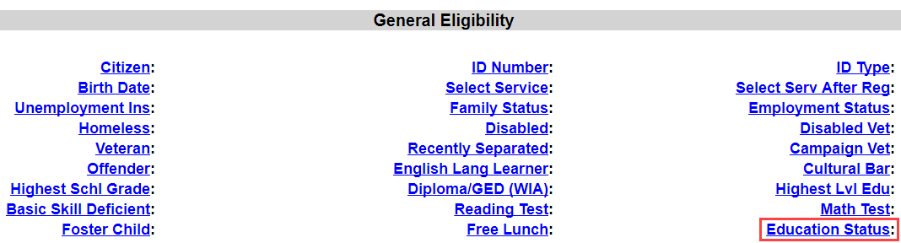
- Active in an education or training service during program participation

A participant is also included in the credential attainment denominator if he or she participates in one of the following educational or training services during program participation:

- Secondary Credential Denominator
  - AB – Adult Basic Education
  - AE – Adult Literacy Education
  - DO – Dropout Recovery/Alternative Secondary School Services (out-of-school youth)
  - DP – Dropout Prevention Services (in-school youth)
  - EW – Education with Workforce Preparation (youth only)

- Postsecondary Credential Denominator
  - AC – Apprenticeship
  - AE – Adult Literacy Education
  - CN – Contextualized Learning
  - ET – Entrepreneurial Training
  - OC – Occupational Skills Training
  - OS – Other Occupational Skills Training
  - PQ – Pre-requisite Training
  - RE – Remedial Training (TAA only)
  - UP – Skills Retraining/Upgrading

What happens in Connecting Colorado to put an individual in the numerator?

Attainment of a credential will be tracked in one of two ways:

- Connecting Colorado Service Screen:

Credential attainment will be captured using a related service with one of the following codes in the ‘Credential’ field with an associated attainment date:
  - HS – High School Diploma or Equivalency
  - AA – AA or AS Diploma/Degree
  - BA – BA or BS Diploma/Degree
  - OL – Occupational Skills Licensure
  - CT – Occupational Skills Certificate
  - OC – Other recognized Diploma, Degree, or Certificate



Please note, graduate/post graduate degrees (as indicated with a ‘PS – Graduate/Post Graduate’ code is not applicable for WIOA Title I performance and therefore does not put an individual into the credential attainment numerator.

- Connecting Colorado Exit Screen:

Credential attainment can also be captured by entering one of the following codes in the ‘Type 1,’ ‘Type 2,’ or ‘Type 3’ fields (along with an associated attainment date up to four quarters after exit):
  - HS – High School Diploma or Equivalency
  - AA – AA or AS Diploma/Degree
  - BA – BA or BS Diploma/Degree
  - OL – Occupational Skills Licensure
  - CT – Occupational Skills Certificate
  - OC – Other recognized Diploma, Degree, or Certificate


Please note, graduate/post graduate degrees (as indicated with a ‘PS – Graduate/Post Graduate’ credential attainment code is not applicable for WIOA Title I performance, and therefore does not put an individual into the credential attainment numerator.

If a participant obtains a secondary school diploma or equivalent, he or she must also be employed or in an education or training program leading to a postsecondary credential within one year (four quarters) after exit.

In addition to the completion of one or more of the credential types (and associated date(s)), employment information must also be captured in one of the following fields during at least one of the four quarters after exit:
- Employed After Exit (please note, this also includes CUBS data)
- Youth Placement (this is limited to youth during the second and fourth quarters—to indicate employment in either the first or third quarter, complete the ‘Employed After Exit’ field)

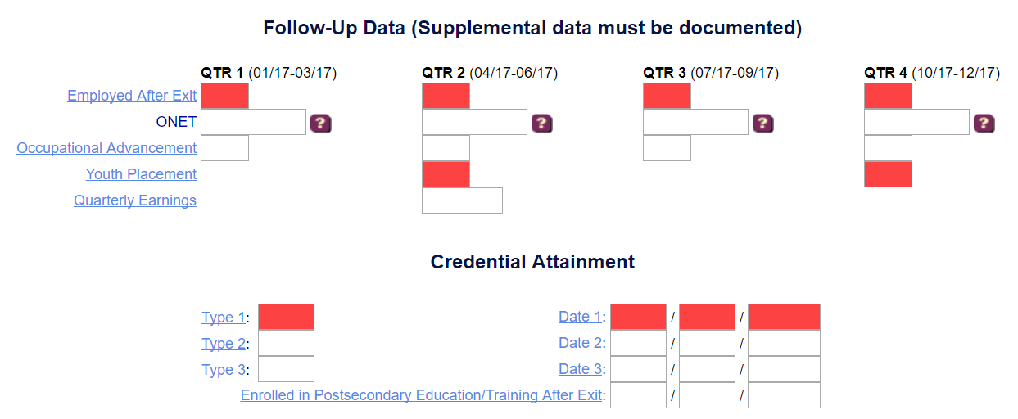

- Obtains a secondary school diploma or equivalent and is in a training program leading to a postsecondary credential within one year after exit

In addition to the completion of one or more of the credential types (and associated date(s)), a postsecondary education/training enrollment date must be entered in the ‘Enrolled in Postsecondary Education/Training After Exit field:



Please note, graduate/post graduate degrees (as indicated with a ‘PS – Graduate/Post Graduate’ credential attainment code is not applicable for WIOA Title I performance, and therefore does not put an individual into the credential attainment numerator.

